**Docker Swarm:**

* It will manage the multiple containers and distribute the load equally among all the worker nodes.
* It consists of master node or manager server and worker nodes.
* First create the docker master server and worker node on EC2 dashboard.We need to install docker on worker node also.
* We can execute the **docker swarm init** command on master server.It will generate the token.
* We can copy this token and paste it on worker node.

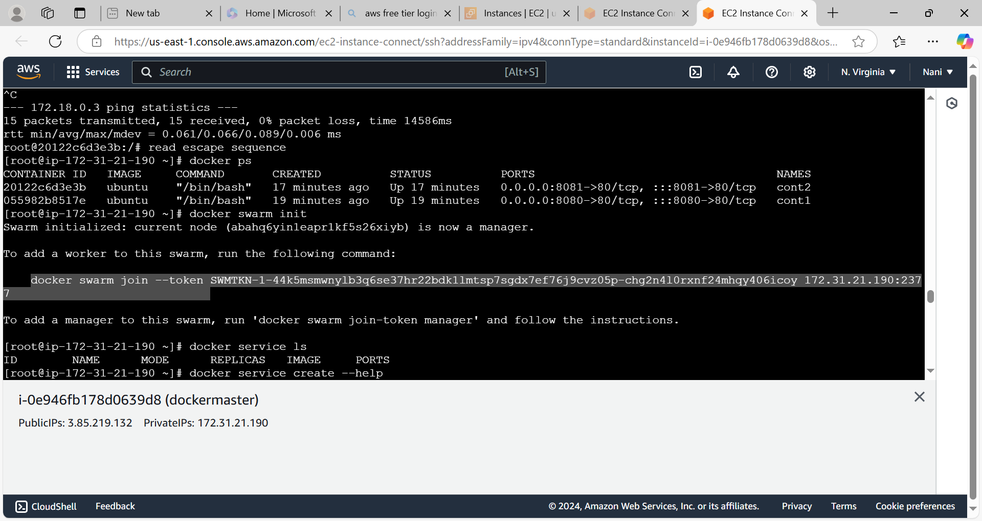

* Create the service by using **docker service create --name service name --publish portnumber:imageport number image name** command like below image.

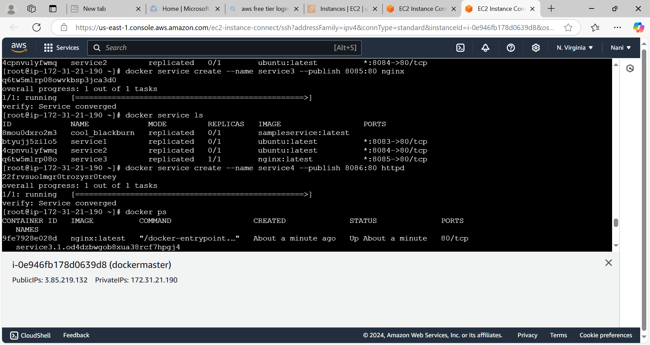

* To list services by using **docker service ls** command.

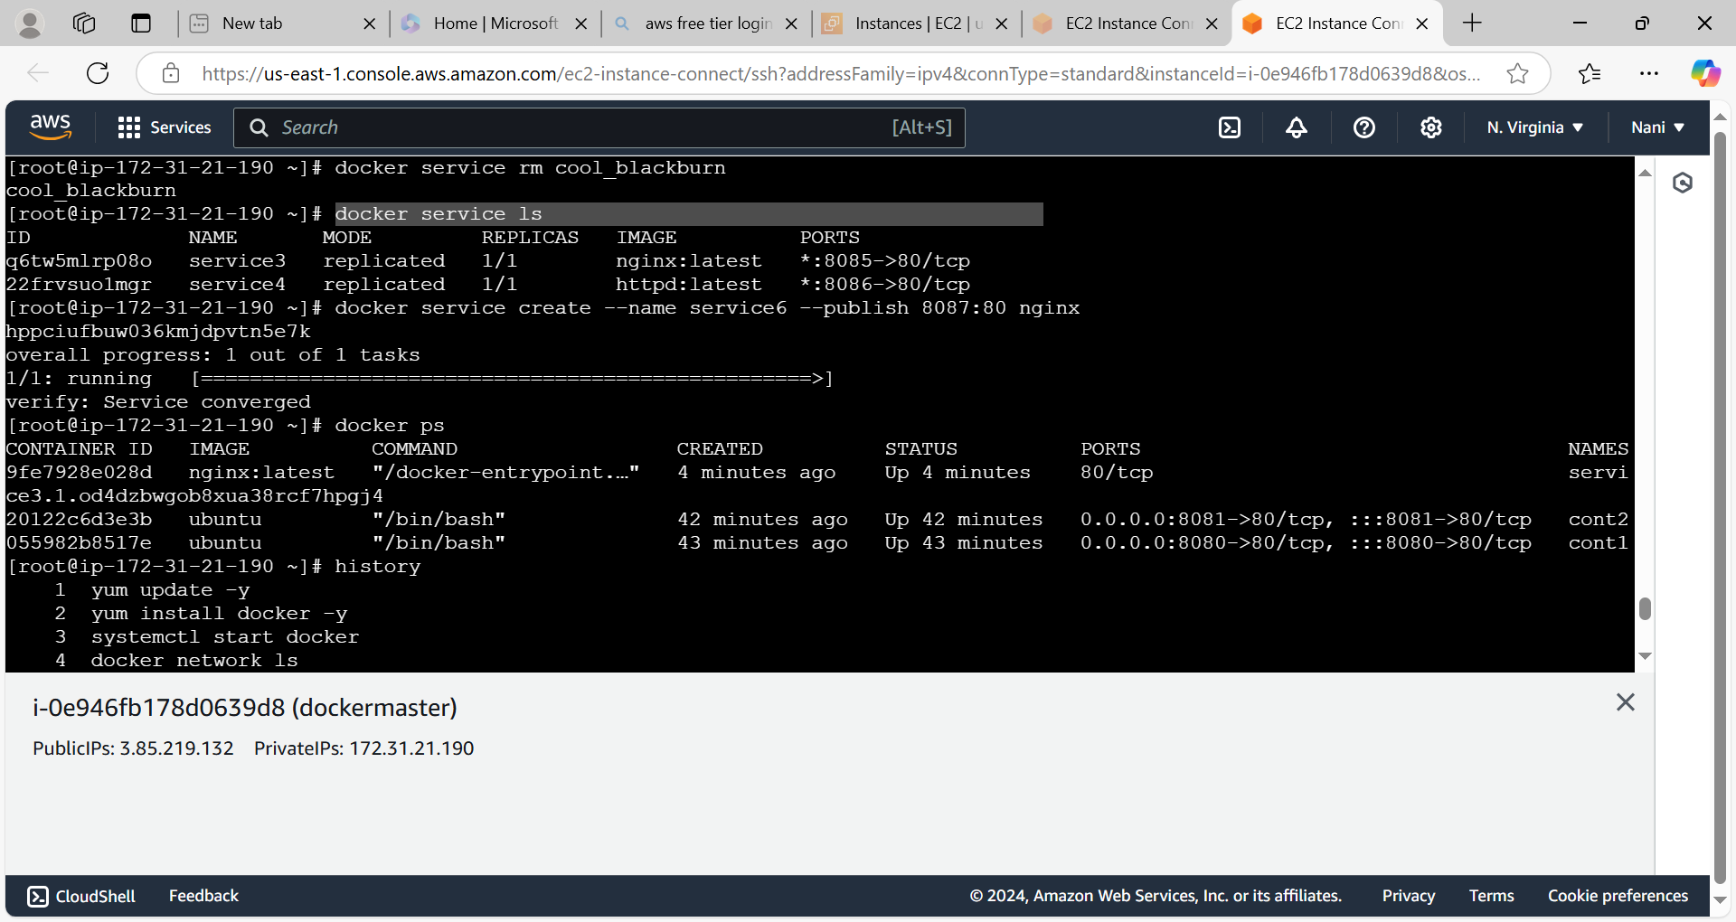

* When we create the service it will create the container and run that container on master node or worker node.
* In this case service3 container has created on master node and service4 and service6 container has created on worker node.

